Encapsulation

📌 Definition:
# Source: AI Source: Provided by: [Data Path: Persons Table -> ID Column: 1, Name_En Column: Motasem Essam] -> From: [ChatGPT] on [12/9/2025]
Encapsulation is an OOP principle that means bundling data (variables) and methods (functions) together into a single unit (a class) and restricting direct access to some of the object’s components.

🧠 Simple idea:
# Source: AI Source: Provided by: [Data Path: Persons Table -> ID Column: 1, Name_En Column: Motasem Essam] -> From: [ChatGPT] on [12/9/2025]
Encapsulation = “Protect the data inside the object” 🔒

🔍 Key characteristics:
# Source: AI Source: Provided by: [Data Path: Persons Table -> ID Column: 1, Name_En Column: Motasem Essam] -> From: [ChatGPT] on [12/9/2025]
- 📦 Combines data + methods in one class
- 🔒 Hides internal data from outside access
- ⚙️ Controls access using getters and setters
- 🛡️ Improves security and data integrity
- 🧩 Makes code easier to maintain

📌 Example (Java-style):
# Source: AI Source: Provided by: [Data Path: Persons Table -> ID Column: 1, Name_En Column: Motasem Essam] -> From: [ChatGPT] on [12/9/2025]
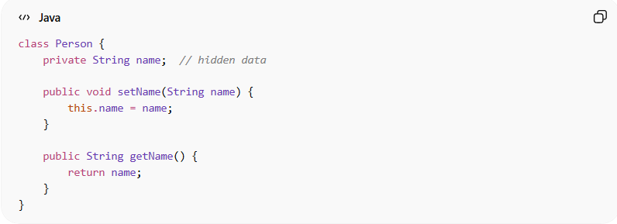
class Person {
private String name; // hidden data

public void setName(String name) {
this.name = name;
}

public String getName() {
return name;
}
}

📌 Usage:
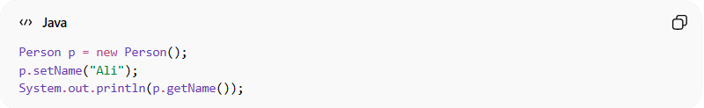
Person p = new Person();
p.setName("Ali");
System.out.println(p.getName());
👉 The variable name is:
- 🔒 Private (hidden)
- ✅ Accessed only through methods

⚙️ Why encapsulation is important:
# Source: AI Source: Provided by: [Data Path: Persons Table -> ID Column: 1, Name_En Column: Motasem Essam] -> From: [ChatGPT] on [12/9/2025]
- 🛡️ Prevents direct modification of data
- 🔐 Protects object integrity
- 🧱 Reduces complexity
- 🔄 Makes code more flexible and maintainable

🎯 Summary:
# Source: AI Source: Provided by: [Data Path: Persons Table -> ID Column: 1, Name_En Column: Motasem Essam] -> From: [ChatGPT] on [12/9/2025]
Encapsulation ensures that an object controls how its data is accessed and modified, improving security and structure in OOP.

